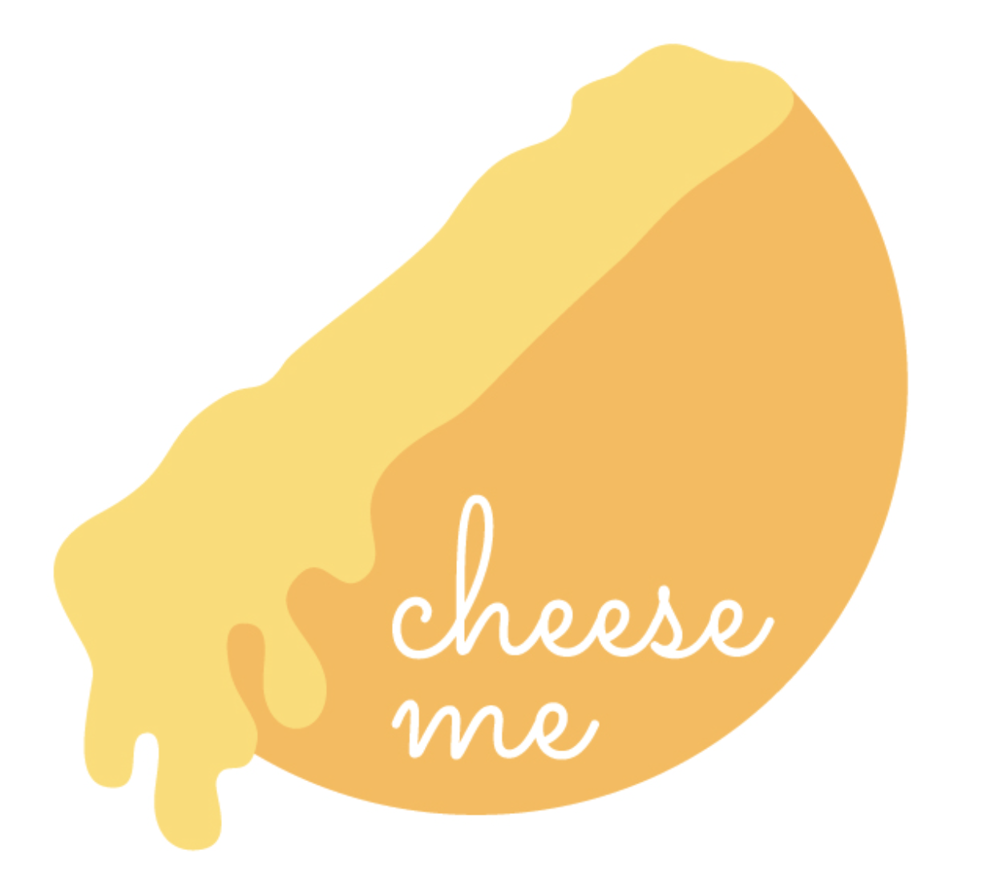
CHEESE ME
VANCOUVER

RACLETTE REFRESHMENT HALF MEAL PORTION
Service duration: 2 hours with ONE station (2-3 traditional raclette melters handled by a professional chef)

ALL OPTIONS INCLUDE 3.5oz OF VARIOUS RACLETTE CHEESES, FRESHLY BAKED ARTISANAL BAGUETTE SLICES, GHERKINS, AND CORNICHONS. A MINIMUM OF 80 PERSONS IS REQUIRED.

- ACTIVE RACLETTE SCRAPING STATION $28 per person
Experience the delightful tradition of raclette with TWO varieties of raclette cheese wheels from Cheese Me's curated selection. Our skilled raclette chef will scrape the melted cheese directly onto slices of artisanal French baguette in front of your guests.

- RACLETTE PARTY $36 per person
This option includes the Active Raclette Scraping Station, along with freshly cooked nugget potatoes and Cheese Me's signature assortment of pickles and vegetables — gherkins, cornichons, pepperoncini, olives, and greens.

- GOURMET RACLETTE $48 per person
Enhance your Raclette Party experience with Cheese Me’s selection of high-end cured meats and cheese, featuring premium products from France, Italy, and Switzerland. This option comes with grilled vegetables and various greens.

RACLETTE DINING FULL MEAL PORTION
Service duration: 2 hours with TWO stations (4-5 traditional raclette melters handled by two professional chefs)

ALL OPTIONS INCLUDE 7oz OF VARIOUS RACLETTE CHEESES AND DOUBLE THE AMOUNT OF FRESHLY BAKED ARTISANAL BAGUETTE SLICES, GHERKINS, AND CORNICHONS. A MINIMUM OF 80 PERSONS IS REQUIRED.

- ACTIVE RACLETTE SCRAPING STATIONS $36 per person
Experience the delightful tradition of raclette with THREE varieties of raclette cheese wheels from Cheese Me's curated selection. Our skilled raclette chefs will scrape the melted cheese directly onto slices of artisanal French baguette in front of your guests.

- RACLETTE PARTY $44 per person
This option includes TWO Active Raclette Scraping Stations, along with freshly cooked nugget potatoes and Cheese Me's signature assortment of pickles and vegetables — gherkins, cornichons, pepperoncini, olives, and greens.

- GOURMET RACLETTE $60 per person
Enhance your Raclette Party experience with Cheese Me’s selection of high-end cured meats and cheese, featuring premium products from France, Italy, and Switzerland. This option comes with grilled vegetables and various greens.

CHEESE WHEEL CAKE .

Elevate your special events and wedding celebrations with our unique cheese wheel creations and cake decorations. Our professional team crafts exquisite cheese displays and beautifully decorated cakes, perfect for any occasion. Receive a discount on a Cheese Wheel Cake with any catering service.

Custom Cheese Wheel Creations: Meticulously arranged cheese displays that add a touch of elegance to your event.
Elegant Cake Decorations: Stunning cakes designed to complement the theme of your special occasion.
Professional Service: After the event, our experienced team will portion and serve the cheese, ensuring a seamless experience for you and your guests.

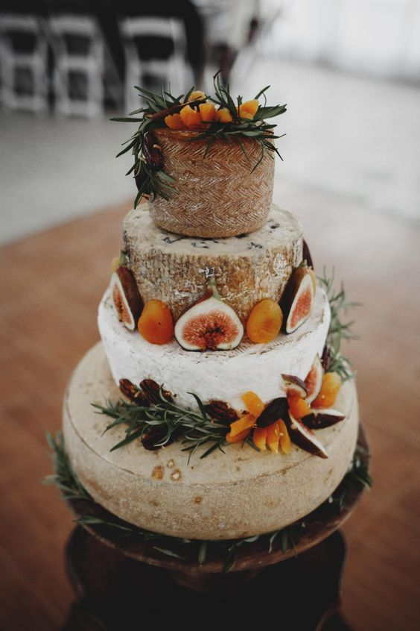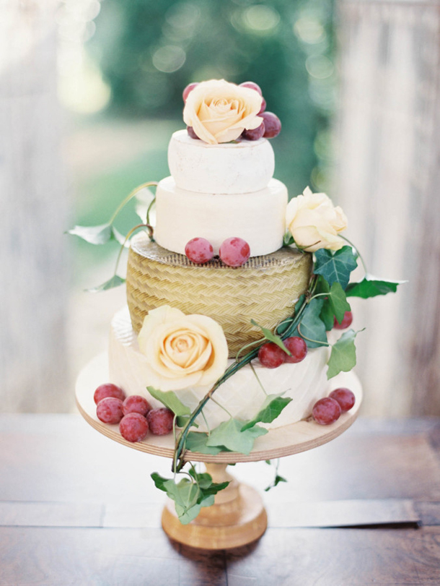

CHEESE ME SIGNATURE SERVICE .

- BREAD BOWL FONDUE $14 per person
Savor our special-recipe fondue served in a petit bread bowl, along with seasonal sides. This add-on option can be added to any catering service.

- Traveling Service $1.50 per km per vehicle
We offer raclette service throughout South BC. There is no travel fee for service within a 30 km radius of downtown Vancouver. For every kilometer in excess of 30 km, there will be a fee of $1.50 per vehicle.

Please Note:
Prices are subject to change and are provided as a guide. Rates will be confirmed once you discuss your event details with our service management team. Menus and prices may be adjusted without prior notice.

A 5% GST and 10% service charge will apply to all food.

We highly recommend that you reserve your special day at least 6 weeks in advance.

